Mini Project

**Name of Project:** IPL Stats Dashboard

**Software Required:**

* Python
* VS Code
* Python libraries
* IPL Dataset

**Description:**

The IPL Matches Dashboard is an immersive tool crafted for cricket aficionados to explore the intricate details of Indian Premier League (IPL) matches. Leveraging Streamlit, Plotly, and Pandas, it presents a multifaceted analysis of match data. Users can scrutinize team performances, assess head-to-head results, and discern state-wise victories through intuitive visualizations. The platform offers a comprehensive overview of IPL statistics, allowing users to delve into the nuances of each season and team dynamics. Moreover, it sheds light on the correlation between winning the toss and securing a match victory, providing valuable insights into match strategies. With its interactive features and rich visualizations, the IPL Matches Dashboard serves as a go-to resource for IPL enthusiasts, offering a holistic understanding of match dynamics and trends over the years. Whether for casual fans or seasoned analysts, this dashboard provides a compelling exploration of IPL cricket statistics.

**Streamlit:-** Streamlit is a powerful open-source Python library designed for creating interactive web applications with minimal effort. It simplifies the process of building data-driven web applications by allowing developers to focus on writing Python code rather than dealing with the complexities of web development. With Streamlit, developers can quickly prototype and deploy applications that are intuitive and responsive.

**Steps:**

Here are the steps to create the IPL Matches Dashboard project using Streamlit:

1. **Set Up Your Environment:**

- Install Streamlit, Pandas, Plotly, and any other necessary libraries.

- Create a new Python script for your project.

2. **Load the Data:**

- Import the necessary libraries such as Streamlit and Pandas.

- Load the IPL matches dataset into a Pandas DataFrame.

3. **Create Sidebar Widgets:**

- Use Streamlit's sidebar feature to create widgets for user input.

- Include widgets for selecting teams, choosing color themes, and selecting seasons.

4. **Visualize IPL Wins by Indian State:**

- Filter the dataset to count the number of wins by state.

- Use Plotly Express to create a choropleth map showing wins by state.

- Display the map using Streamlit.

5. **Display Team Wins DataFrame:**

- Count the number of wins for each team.

- Convert the result to a DataFrame.

- Use Streamlit's `st.dataframe` function to display the DataFrame.

6. **Visualize Head-to-Head Results:**

- Filter the dataset to count the head-to-head results between selected teams.

- Create a pie chart or bar chart using Plotly Express to visualize the results.

- Display the chart using Streamlit.

7. **Visualize Wins per Team in Selected Season:**

- Filter the dataset to count the number of wins per team in the selected season.

- Create a line chart using Plotly Express to visualize the wins per team.

- Display the chart using Streamlit.

8. **Visualize Toss Winner vs. Match Winner:**

- Filter the dataset to count the number of matches where the toss winner also won the match.

- Create a pie chart using Plotly Express to visualize the toss-win correlation.

- Display the chart using Streamlit.

9. **Run the Streamlit Application:**

- Use the `streamlit run` command to run your Python script.

- Access the Streamlit dashboard in your web browser and interact with the widgets and visualizations.

10. **Iterate and Improve:**

- Refine the dashboard layout, visualizations, and functionality based on feedback.

- Experiment with additional features, such as adding more interactive widgets or integrating other data sources.

**Results:**

1. Interactive Chloropeth Map for each team win overall.

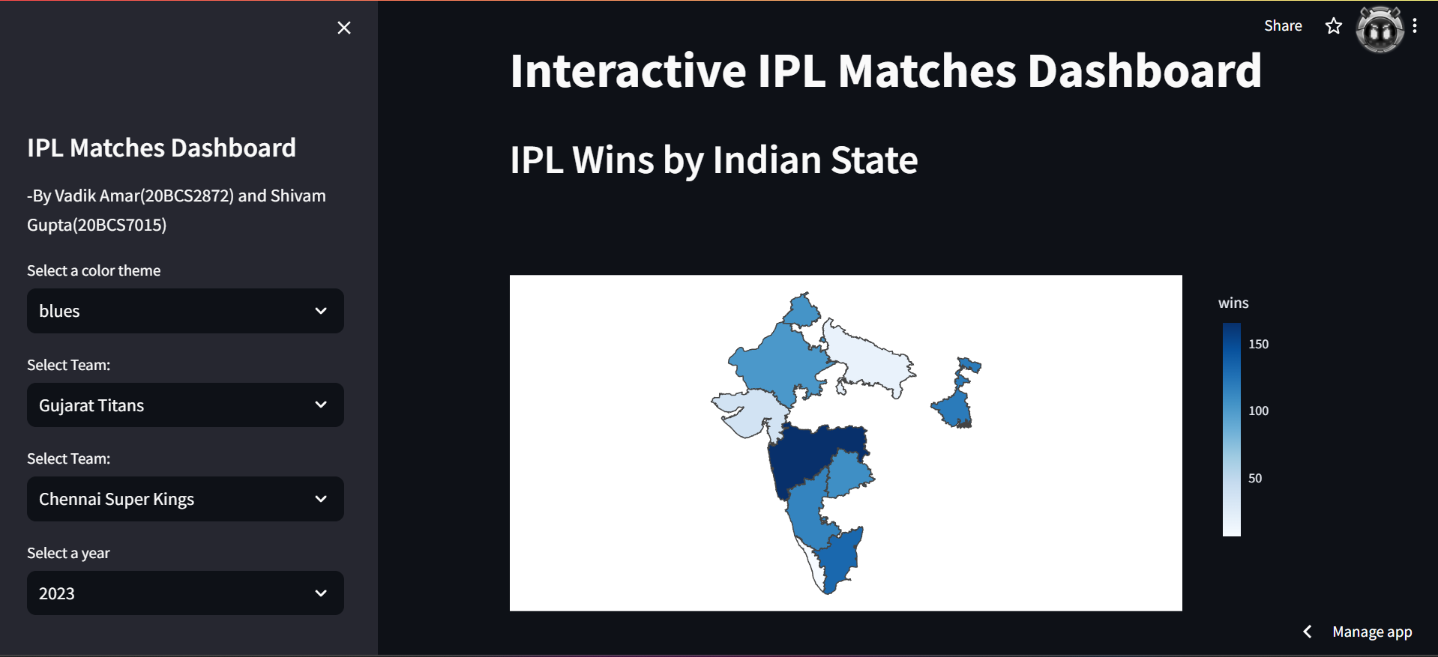

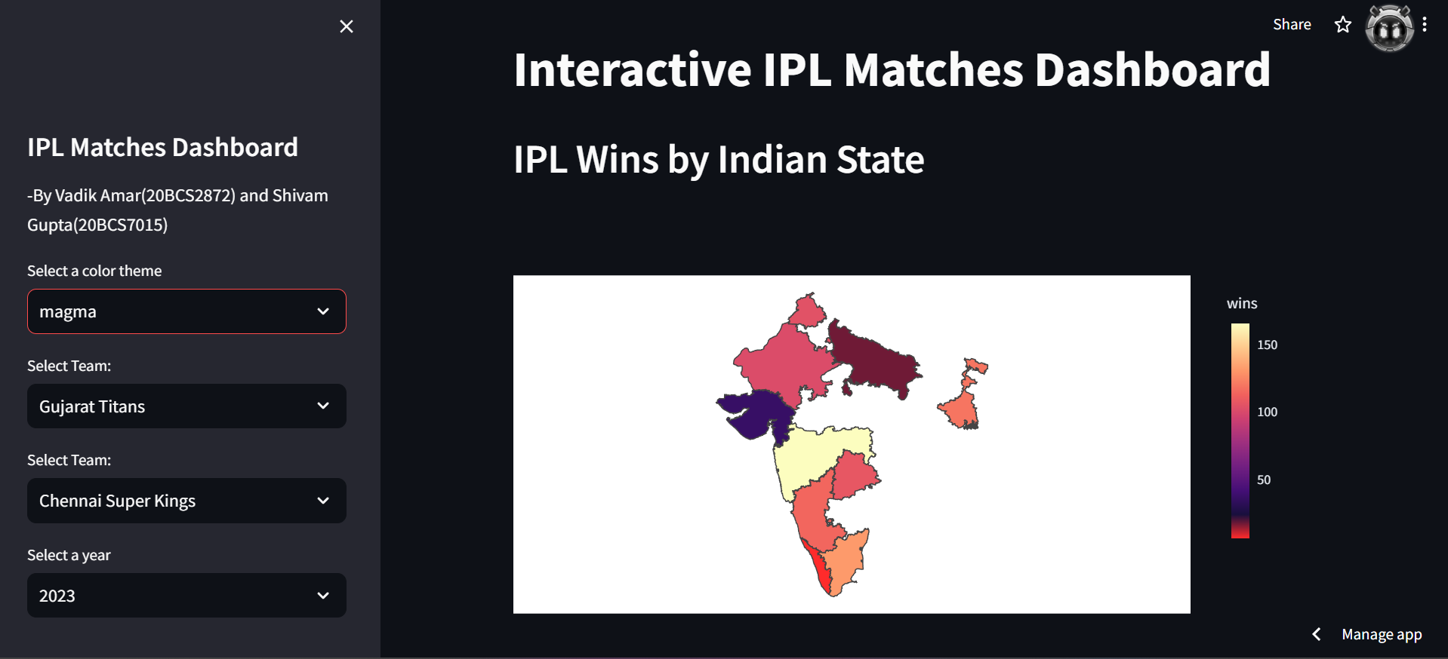

1. Table for each team win overall.

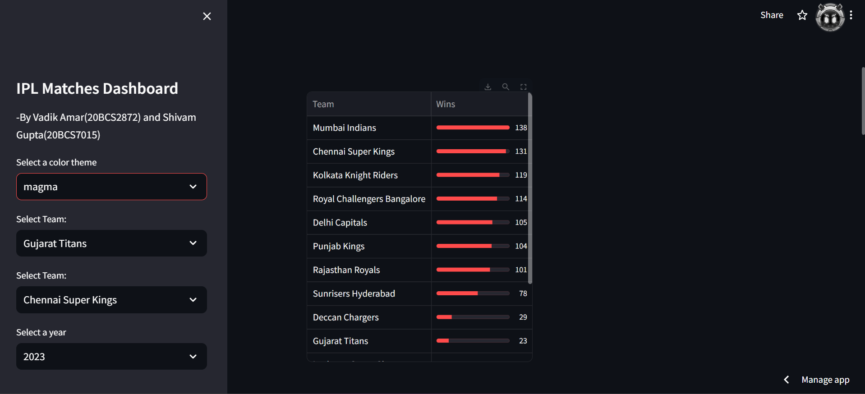

1. Interactive pie chart for head to head results overall.

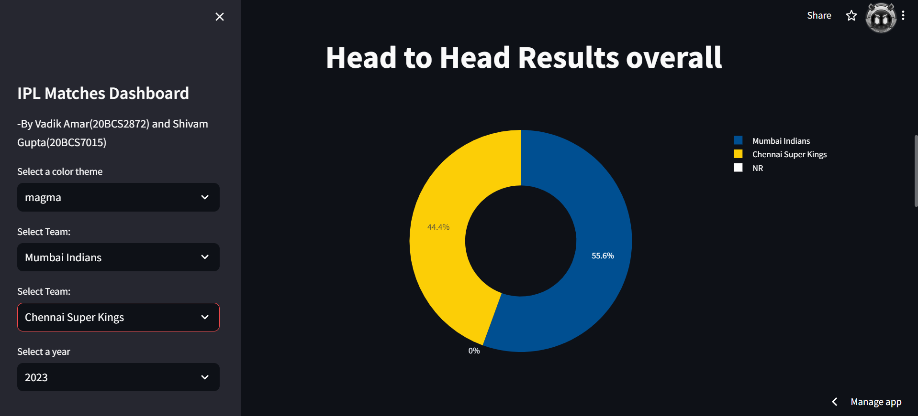

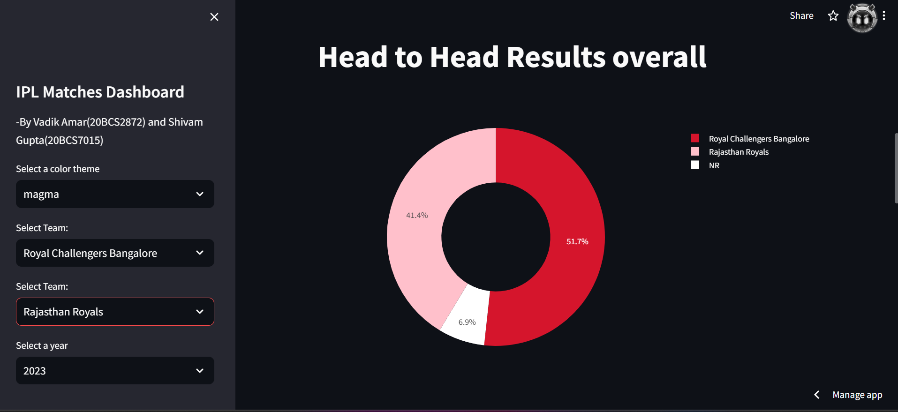

1. Interactive line graph for head to head results overall.

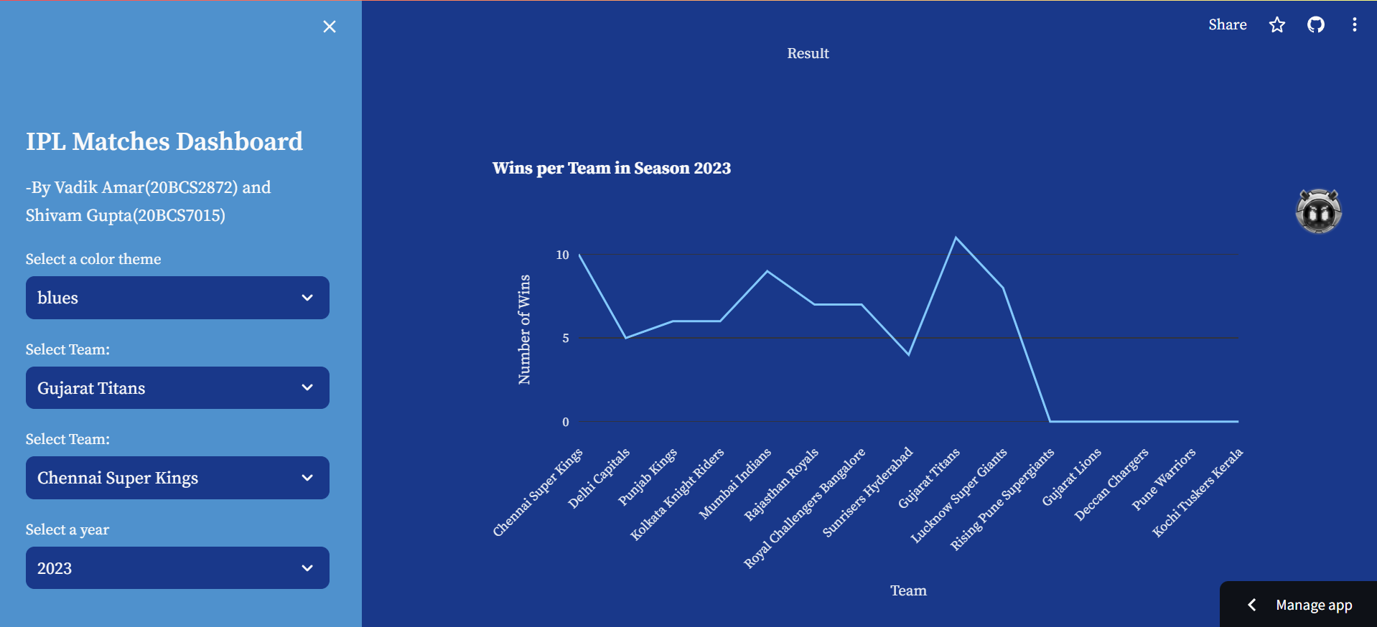

**Conclusion:**

In conclusion, the IPL Matches Dashboard represents a comprehensive exploration of Indian Premier League cricket data, crafted through the integration of Streamlit's simplicity, Pandas' data manipulation capabilities, and Plotly's interactive visualization tools. This project offers cricket enthusiasts an immersive experience, allowing them to dissect team performances, analyze head-to-head matchups, and uncover trends across seasons. By leveraging Streamlit's user-friendly interface, users can effortlessly navigate through the dashboard, gaining valuable insights into the dynamics of IPL matches. Moreover, the correlation between toss wins and match outcomes provides intriguing insights into the game's strategic nuances. As an accessible and insightful resource, the IPL Matches Dashboard stands as a testament to the power of Python libraries in transforming complex datasets into actionable insights, enriching the experience of cricket enthusiasts and data analysts alike.